PhishGuard
HACK-O-WEEK | WEEK 7-8
Error Handling, GitHub, and NPM

Section 1: Title
Hack-O-Week • Week 7-8 • Error Handling, GitHub, and NPM. This report connects the college assignment to the inspected PhishGuard source code.

Section 2: Objective
Explain how failures are handled and how package scripts and version-control practices support reliable PhishGuard development.

Section 3: Theory
Error handling. try/catch catches expected failures at boundaries such as parsing input, browser storage, and network requests. A useful message explains what the user can correct. A custom error class can attach a stable error type to a message.
Git and GitHub. A repository tracks source changes. Commits record changes, branches isolate work, merges integrate a branch, and pull requests support review. Collaboration history must be established by repository evidence.
NPM. package.json defines dependencies and runnable scripts. npm init creates a new project manifest; npm install resolves packages from the manifest and lockfile. In frontend, npm run dev starts Vite and npm run build creates the production bundle. npm run test is not configured.

Section 4: Implementation in PhishGuard
The frontend API client checks response.ok and extracts FastAPI detail text where possible. URLScanner catches request rejection and presents a message. Backend main.py converts URLAnalyzer ValueError to HTTP 422 and unexpected exceptions to a generic HTTP 500. history.js catches malformed localStorage JSON and storage write failures. The workspace root has no .git directory or Git history. frontend/package.json declares dev, build, lint, and preview; it has no test script. NPM commands apply in frontend, while backend dependencies are installed with pip. For a new Node project, npm init (often npm init -y) creates package metadata; PhishGuard already has its frontend package.json and lockfile.

Section 5: Code Explanation
analyzeUrl error handling
Source: frontend/src/services/api.js
Actual implementation. HTTP errors become JavaScript Error objects with a server detail or fallback; malformed error bodies do not hide the original failure. The corresponding code is in this week’s companion Code_Examples.md file.
analyze_url route
Source: backend/app/main.py
Actual Python/FastAPI implementation, not JavaScript try/catch. It distinguishes invalid input from unexpected server errors. The corresponding code is in this week’s companion Code_Examples.md file.
actual scripts and dependencies
Source: frontend/package.json
Actual manifest. npm run dev/build/lint/preview exist; npm test and npm run test do not. npm install installs frontend dependencies from package.json and package-lock.json. The corresponding code is in this week’s companion Code_Examples.md file.
Custom JavaScript error class
Source: Educational example (not in PhishGuard)
Educational JavaScript example. The current project uses built-in Error and Python ValueError; it does not define a custom JavaScript error class. The corresponding code is in this week’s companion Code_Examples.md file.

Section 6: Working Flow
- The browser validates input and sends a POST request.
- The API client checks the HTTP status and parses a response or error detail.
- FastAPI maps ValueError to 422 and unexpected failures to 500.
- During development, npm run dev starts Vite; npm run build produces the frontend build.
- A future GitHub workflow can use feature branches and pull requests; no existing Git activity can be verified here.

Section 7: Learning Outcome
Error boundaries preserve useful feedback across browser and API layers. package.json documents the real frontend workflow, and Git practices should be reported as a recommended workflow unless repository history exists.

Section 8: Code Implementation Screenshots
Captured from the project source file open in Visual Studio Code. Captions identify the displayed file. Code examples are in the companion Code_Examples.md file, not in this Word report. Educational examples there are labeled and are not application code.
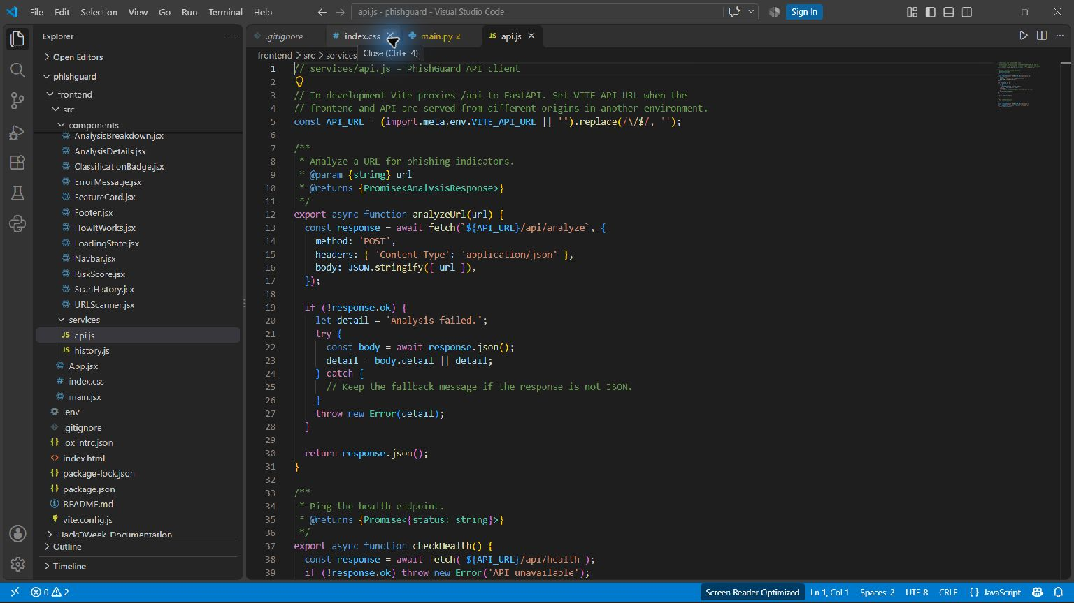
API status checks and response errors — frontend/src/services/api.js
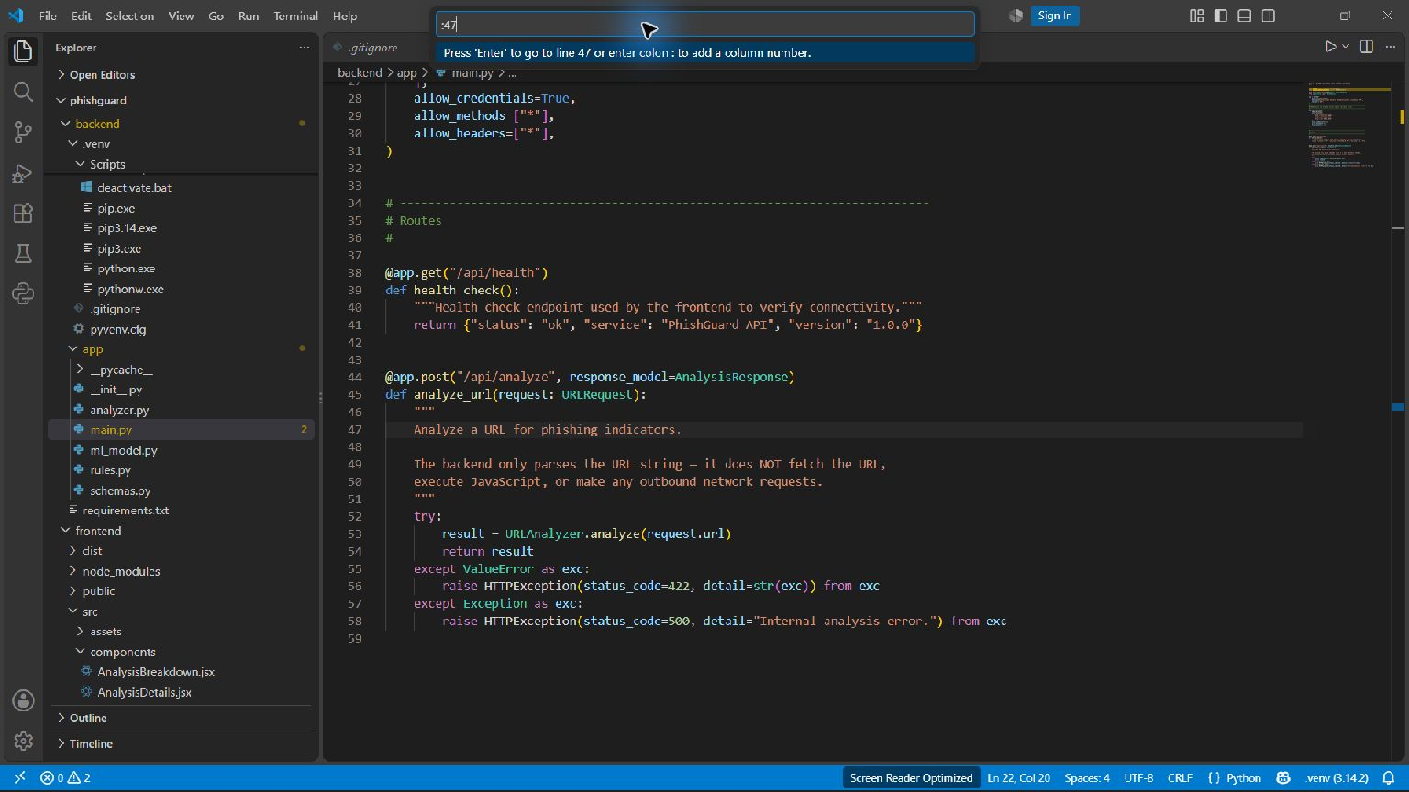
FastAPI route and exception mapping — backend/app/main.py

